How Euclid MER VIS disc and bar geometry are measured
Current results 20 October 2026
Adaptive Photutils pipeline with image-based centre checks
This guide explains how the disc and bar geometry are measured and shows galaxy examples. Good-looking numerical outputs remain provisional until their physical component identification is checked.

What an ellipse measurement means
An isophote is a contour of equal surface brightness. Photutils fits ellipses to these contours at successive semi-major axes, returning a centre, ellipticity, orientation, intensity, errors and convergence information. The outer-disc contours provide a projected axis ratio and disc position angle (PA); an inner stable elongated profile can provide an observed bar PA.

Preprocessing and centre validation
The code crops around the catalogue position using the segmentation-area scale r_seg = sqrt(area/pi). Here area is the number of native image pixels assigned to the detected source above the catalogue analysis threshold. It is read from the CSV manifest (sourced from the MER source catalogue, via the Zenodo catalogue), not from the science-image FITS header. This is the detected segmentation footprint, not the cutout rectangle or necessarily all the faint outer light. The quantity represents area in native pixel units; pi is the circle constant (approximately 3.14159), and sqrt means square root. Thus r_seg is the radius, in native pixels, of a circle with that area; it is a size estimate, not a fitted disc radius. Native resolution is retained for r_seg up to 100 pixels; larger galaxies use larger bins. The code subtracts a sigma-clipped background, identifies the target near the centre, masks neighbouring detections and bright compact contaminants, and obtains a moment-based starting shape. Mask removal on retry is labelled.
The brightest smoothed pixel close to the catalogue position seeds the centre. Centres can move during fitting. Inner converged centres provide a new reference if the initial reference rejects too many samples. Failed cases also try catalogue and local-flux centres. A broader extended-light peak is also tested for failed cases, rather than accepting a nearby bright knot. Candidate centres still require checking for foreground-star switches and unresolved cores. Two such candidates were excluded by explicit visual-review overrides in this run. A final retry can remove a fragmented neighbour mask with mild smoothing; this is explicitly flagged because contamination may increase. The selected disc centres are then summarised by their median and scatter. Large offsets and unstable centres are flags, rather than silently accepting a bright off-centre knot as the nucleus.

Which fitted isophotes are retained
Acceptance here refers to one fitted isophote: the ellipse measured at one semi-major-axis radius. That ellipse has its own centre, ellipticity, PA, brightness and numerical diagnostics. The code applies all of the strict tests below to each ellipse. It does not apply these tests just to the galaxy centre, and an accepted ellipse is not automatically identified as the physical disc or bar.

Normal numerical convergence. Photutils must report a numerically valid result and normal convergence (recorded internally as valid=True and stop_code=0). This describes the numerical fitting outcome; it does not establish that the ellipse traces the intended physical structure.
Usable sampling of at least 65%. At least 65% of the sampled positions along that ellipse must supply usable intensity measurements after exclusions. For example, 65 usable positions out of 100 meets this test; 64 does not. This is not the percentage of the galaxy area covered, and it is separate from how many radial ellipses are available.
Estimated ellipticity error below 0.1. Ellipticity is 1 − b/a. The 0.1 limit is an absolute, dimensionless uncertainty reported by the fit, not a PA error and not a 10% relative error. An ellipticity of 0.40 with a reported error of 0.08 passes this particular test; an error of 0.12 does not.
Estimated PA error below 10 degrees. The reported fitting uncertainty in this ellipse’s orientation must be less than 10°. The code converts Photutils’ PA error from radians to degrees. This is a per-ellipse error estimate, distinct from PA RMS scatter across several selected disc ellipses.
Positive brightness and limited centre movement. The background-subtracted fitted intensity must be positive. The ellipse centre must stay within the larger of three fitting-image pixels or 15% of its semi-major axis from the current reference centre. These distances use the same fitting-image pixel units. The reference can be updated during recovery. This test limits displacement; it does not independently verify the nucleus.
Where the thresholds came from. The 65%, 0.1 and 10° limits, and the centre-displacement limits, were chosen in our pipeline code as practical screening rules. They are not Euclid requirements, Photutils defaults or published universal acceptance standards. No completed calibration study establishes these exact cutoffs as optimal for this sample. They need validation using representative visually reviewed cases and tests of sensitivity to alternative thresholds.
Recovery and final galaxy measurements. The code normally seeks at least eight strict accepted ellipses in the overall profile. Labelled relaxed recovery permits 50% usable sampling, ellipticity error below 0.2, PA error below 20° and a larger centre tolerance. It can include fits that reached the iteration limit without normal convergence (stop code 2); selected examples raise iteration_limited_samples. Diverged or gradient-failure results (codes 4/5) are not treated as converged geometry. At least three accepted ellipses are needed to return geometry; disc and bar selection impose further tests. Acceptance remains provisional.
Definitions and implementation. Photutils defines the convergence statuses and parameter errors: https://photutils.readthedocs.io/en/stable/api/photutils.isophote.Isophote.html . Our additional strict and relaxed screening rules are implemented in accepted() in Euclid/adaptive_MER_VIS/fit_adaptive_MER_VIS_geometry.py.

How the disc interval and bar plateau are chosen
An isophote fit describes one ellipse at one radius. Each ellipse contributes one ellipticity point and one PA point at that radius on the two profiles. The colours link the image to the graphs: orange is the candidate bar interval; green is the selected outer-disc interval. The diagram below uses invented values to make the definitions clear.
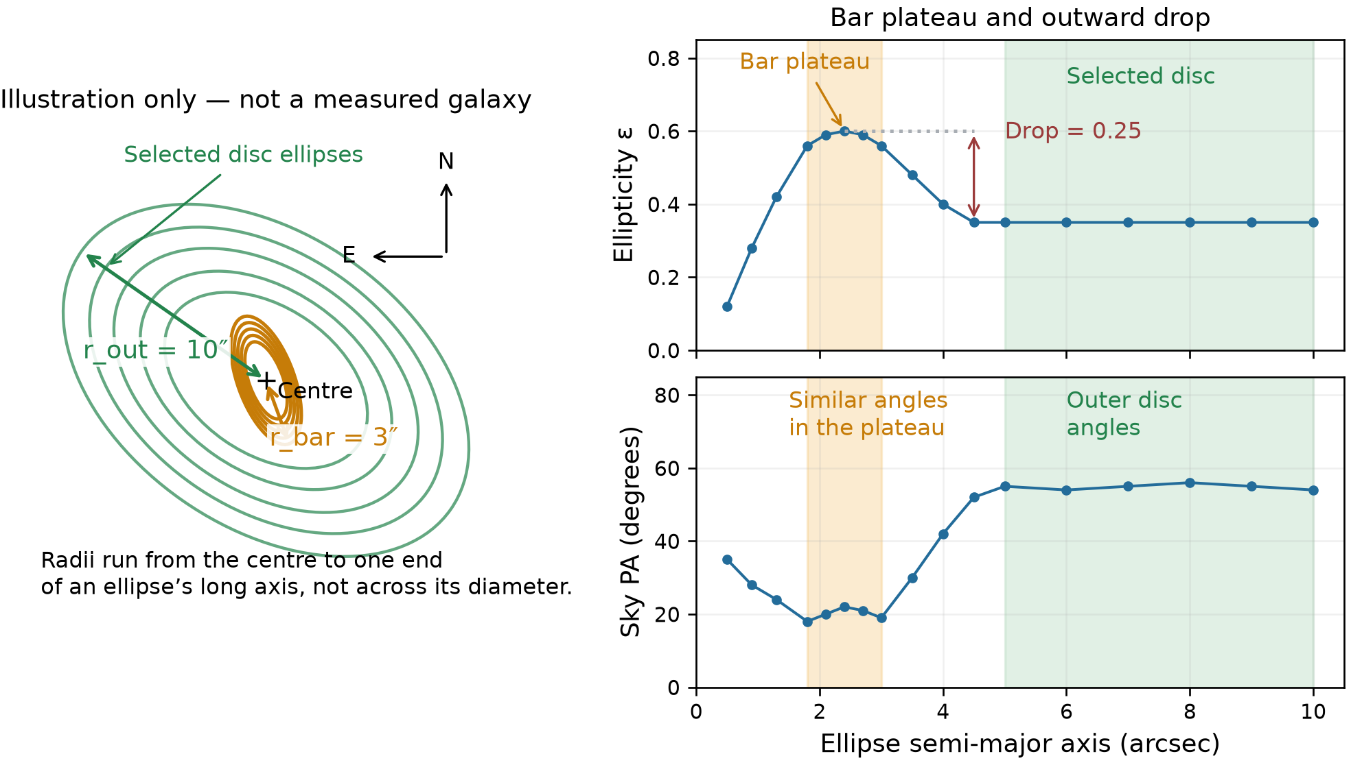
r_out is the semi-major axis of the outermost accepted ellipse in the selected bright profile. It is the outer bound available for disc selection, not the edge of the FITS cutout or a guaranteed physical boundary of the galaxy. r_bar is the semi-major axis of the largest ellipse in the accepted bar plateau. Both are distances from an ellipse centre to one end of its long axis, in arcseconds; neither is a diameter.
The disc interval starts at the larger of half r_out and 1.25 times r_bar, and ends at r_out. In this illustration, r_out = 10″ and r_bar = 3″. Half the outer radius is 5″; 1.25 times the bar end is 3.75″. We therefore use accepted disc ellipses from 5″ to 10″. The gap after the bar helps avoid measuring the bar as part of the disc.
The bar plateau is the orange cluster of high-ellipticity ellipses near a local peak. Their orientations must also be similar, as shown in the lower graph. A plateau need not be perfectly flat: small changes in ellipticity and PA are allowed. Moving outwards, the ellipses become rounder, so ellipticity falls. Here the drop is 0.60 − 0.35 = 0.25. High ellipticity alone is insufficient evidence for a bar.

A measured example of the same definitions
Galaxy −639567775462084647 has five selected bar ellipses and six selected disc ellipses, with no counted geometry flags in the stored run. The image is the native observed cutout, not deprojected or rotated. The annotations below were calculated from its saved profile; no fit was rerun for this explanation.
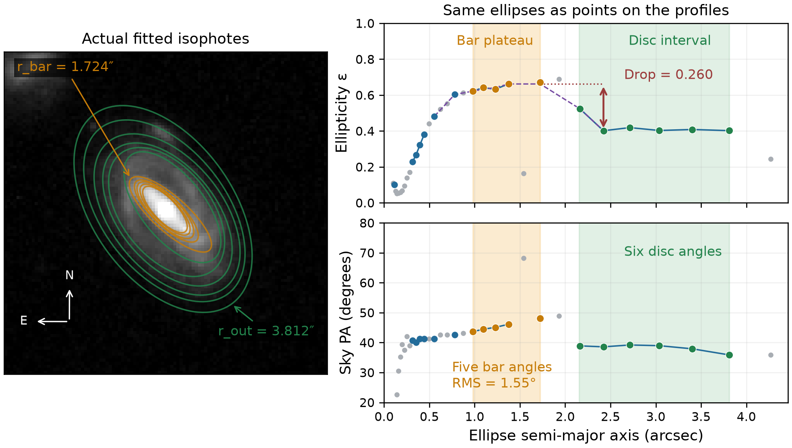
Orange circles on the graphs correspond to the five orange ellipses on the image. Green circles and ellipses identify the selected disc. Blue denotes other accepted measurements; grey denotes excluded measurements. The purple dashed curve is the three-point running median used to locate an ellipticity peak among the accepted search samples. It is not a separate ellipse fit.
Bar ellipse radius (arcsec) | Ellipticity | Sky PA (degrees)
0.978 | 0.622 | 43.62
1.096 | 0.641 | 44.48
1.227 | 0.633 | 45.09
1.374 | 0.662 | 46.13
1.724 | 0.672 | 48.11
The bar PAs vary from 43.62° to 48.11°, with axial RMS scatter of 1.55°. This meets the 10° common bar threshold and the stronger 5° class A threshold. The adopted bar PA is the error-weighted axial mean, 46.34°. These neighbouring ellipses are correlated; five measurements are not five independent confirmations of a bar.
The smoothed peak is 0.662, and the lowest accepted ellipticity in the outward comparison region is 0.402 at radius 2.422″. The recorded drop is therefore 0.260. The highest raw orange point is 0.672; it is not the smoothed peak used in that subtraction.
Here r_out = 3.812″ and r_bar = 1.724″. The disc starts at max(1.906″, 2.155″) = 2.155″. Because fits exist only at discrete radii, its first selected ellipse is at 2.163″; six accepted disc ellipses extend to 3.812″. Their adopted disc PA is 38.60°. The bar and disc directions can differ.

The bar acceptance test and the reported angles

How the plateau and outward drop are tested
The search examines accepted ellipses between 0.5 arcsec and 0.7 times r_out. It smooths their ellipticity values with a three-point median and looks for local peaks of at least 0.20. Around a peak, it extends the plateau while the smoothed ellipticity stays within 0.05 below the peak, with a limit of 12 neighbouring samples on either side. At least three accepted ellipses and plateau PA RMS scatter no greater than 10° are required.
The outward drop is the smoothed peak ellipticity minus the lowest accepted ellipticity in a bounded region beyond that peak. The region extends to the larger of 2.5 times the peak radius or the peak radius plus 1 arcsec. The peak radius is where the candidate peak occurs; it need not equal r_bar, which is the plateau’s outer end. The code uses accepted measurements in this region, not an arbitrarily chosen faint outer pixel or a grey excluded point.
The usual requirement is a drop of at least 0.08. A smaller drop of at least 0.04 can pass if either the outer PA twist or the difference from the preliminary outer-disc PA is at least 10°. Class A additionally requires peak ellipticity at least 0.30, a drop of at least 0.10 and plateau PA scatter no greater than 5°. Accepted candidates missing one or more stronger conditions are class B. The measured example passes all three class A conditions.
A uniformly elongated disc can have high ellipticity and a stable PA without a separate bar plateau and outward drop. Conversely, a peak with strongly changing PA can be caused by spiral structure rather than a bar. Even a passing class A signature remains a candidate: a bulge, ring, arm or contaminant can imitate this profile. These numerical thresholds are operational choices in our pipeline, not universal physical definitions of a bar.

Inclination
For an intrinsically circular thin disc, q = b/a = 1 − ellipticity and inclination i = acos(q). Here a is an ellipse semi-major axis (its long radius), b is its semi-minor axis (its short radius), and q is their dimensionless ratio. The pipeline takes the median selected-disc ellipticity before forming q. The function acos means inverse cosine; its result is converted to degrees. Inclination i measures disc tilt from face-on: q = 1 gives i = 0°, and q = 0.5 gives i = 60°. The intrinsic thickness parameter q0 is the edge-on short-to-long axis ratio assumed for the model; this project uses q0 = 0, meaning an infinitely thin disc. The supplied alternative method uses q0 = 0.2, so its inclinations need not match even for the same measured q.

PA convention and mosaic orientation
Photutils pixel angles start at positive image x (increasing pixel column) and turn towards positive image y (increasing pixel row coordinate). WCS means World Coordinate System: the FITS mapping from pixel positions to celestial coordinates. We use WCS to express an ellipse direction as local East and North sky offsets, then compute atan2(East, North) modulo 180°. atan2 is the two-argument inverse tangent; here it gives an angle measured from North towards East. Modulo 180° puts the result in the range 0° to less than 180°, because either end of an ellipse axis describes the same orientation. PA means position angle: 0° North–South, 45° northeast–southwest, 90° East–West, 135° northwest–southeast. It is counterclockwise on North-up East-left images. The native mosaic grid is preserved. Across the sample, local North differs from pixel-up by median 0.141° and maximum 0.604° because of the projection.
The additional +90° is applied only to the converted Euclid catalogue comparison, not to our Photutils PA or the pixels. A different documented versus actual detection-image reference is plausible but unconfirmed. All bar angles here are observed, not deprojected.

How to interpret warnings
Sparse disc sampling: Fewer than six selected accepted disc ellipses, or a largest radial gap above half the span. RMS means root mean square: the square root of the mean squared angular deviations, after wrapping axis differences into −90° to +90°. This scatter is measured in degrees and is not the uncertainty of the mean PA. PA stability is not confidently assessed; see the final explanation page.
Disc PA varies across radius: Accepted disc sky PA scatter exceeds 10°, with at least six selected accepted ellipses and no radial gap exceeding half the selected span. Nearly-face-on discs are exempt. This is a screening rule, not a calibrated confidence test.
No accepted bar; disc retained: No bar candidate passes; a disc estimate may remain useful.
Changing disc ellipticity: Selected disc ellipticity spans more than0.15.
Bar identification uncertain because of a small interval: The selected candidate interval ends below 1.5 arcsec. This may be an unresolved bar or a bulge, spiral arm or noise feature. It does not establish the presence of a bar.
Disc interval fallback: The normal disc interval had fewer than three samples.
Bar and disc intervals close: Disc samples approach or overlap the selected bar interval.
Small disc: Bright outer radius is below 2 arcsec.
Weaker accepted bar signature: An accepted class B candidate meets the broader bar-profile test but misses one or more class A thresholds. See the class A and B explanation at the end of this document.
Large centre offset: Median selected-disc centre is farther from the catalogue position than the operational threshold.
Relaxed recovery: Recovery used broader acceptance criteria; inspect the result.
Iteration-limited samples: At least one selected sample reached the iteration limit.
Star mask removed in retry: A retry without the compact-star mask was used.
Neighbour mask removed in recovery: Fragmented target segmentation prompted a retry without the neighbour mask; inspect contamination carefully.
Centre changes across disc: Selected-disc centres vary beyond the operational threshold.
Short accepted profile: Fewer than ten accepted isophotes in the returned profile.
High inclination: The inferred inclination is at least 80°.
Nearly face-on is information, not a defect: 59 fitted discs have q>0.90. PA is intrinsically uncertain for a circle, while deprojection is small. The manifest separates codex_information from counted quality flags. QI means quality issue; NoQI means no counted quality issues. QI also includes failed fits and partial requested coverage, which does not necessarily mean the galaxy itself is truncated.

An example of checking the galaxy centre
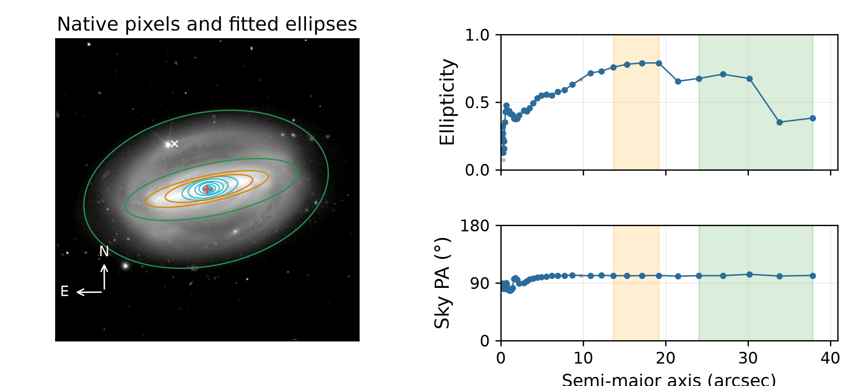
Galaxy 2700376345666189458. Disc PA 101.52°; bar PA 101.48°; inclination 71.05°. Method: recentred. Accepted ellipses: 43. Flags: Large centre offset, Changing disc ellipticity. Centre offset: 17.320 arcsec.
The white catalogue marker lies away from the bright central galaxy light; the fitted ellipse centre is the red marker. This demonstrates why the catalogue position must be checked. The large centre offset remains a review flag even when the fitted centre looks plausible. The original image and catalogue position are preserved, and this example is not presented as a single-flag case.

Example 1 with no counted geometry issues
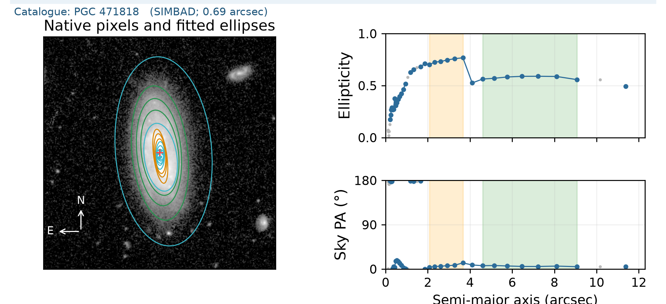
Galaxy -623118358499243253. Disc PA 5.91°; bar PA 7.05°; inclination 65.36°. Accepted disc ellipses: 7. Flags: none. Centre offset 0.128 arcsec.
Green marks the selected disc interval; orange marks the accepted bar. Look for stable outer PA, a modest ellipticity variation and a stable inner bar direction. A NoQI label screens the numerical conditions but does not independently validate the physical component identification.

Example 2 with no counted geometry issues
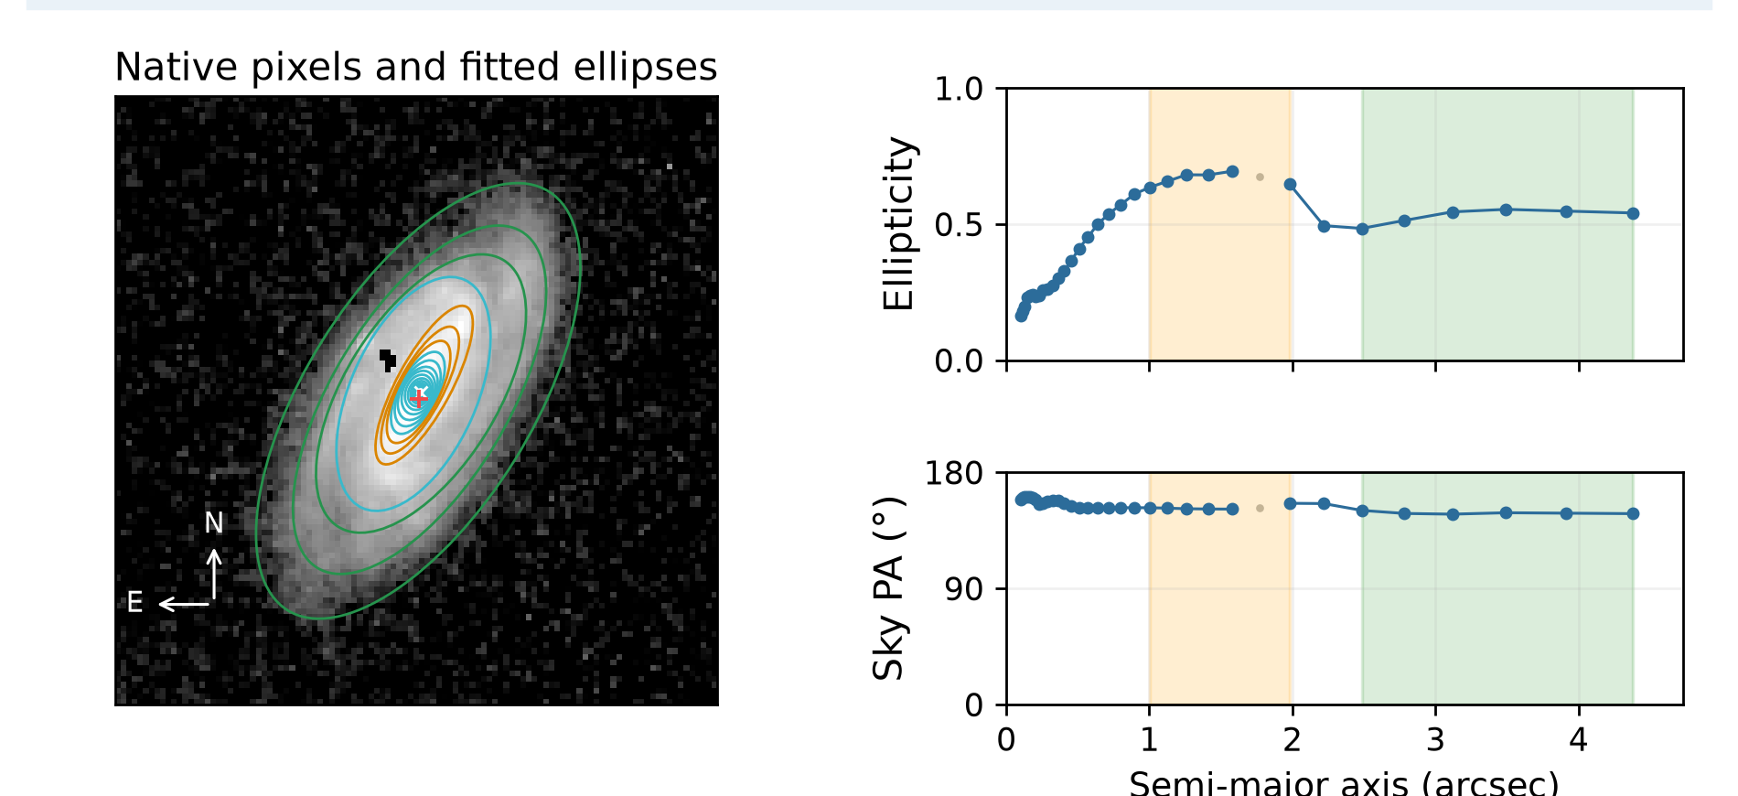
Galaxy -527683439283031054. Disc PA 148.42°; bar PA 152.60°; inclination 62.82°. Accepted disc ellipses: 6. Flags: none. Centre offset 0.107 arcsec.
Green marks the selected disc interval; orange marks the accepted bar. Look for stable outer PA, a modest ellipticity variation and a stable inner bar direction. A NoQI label screens the numerical conditions but does not independently validate the physical component identification.

Example 3 with no counted geometry issues
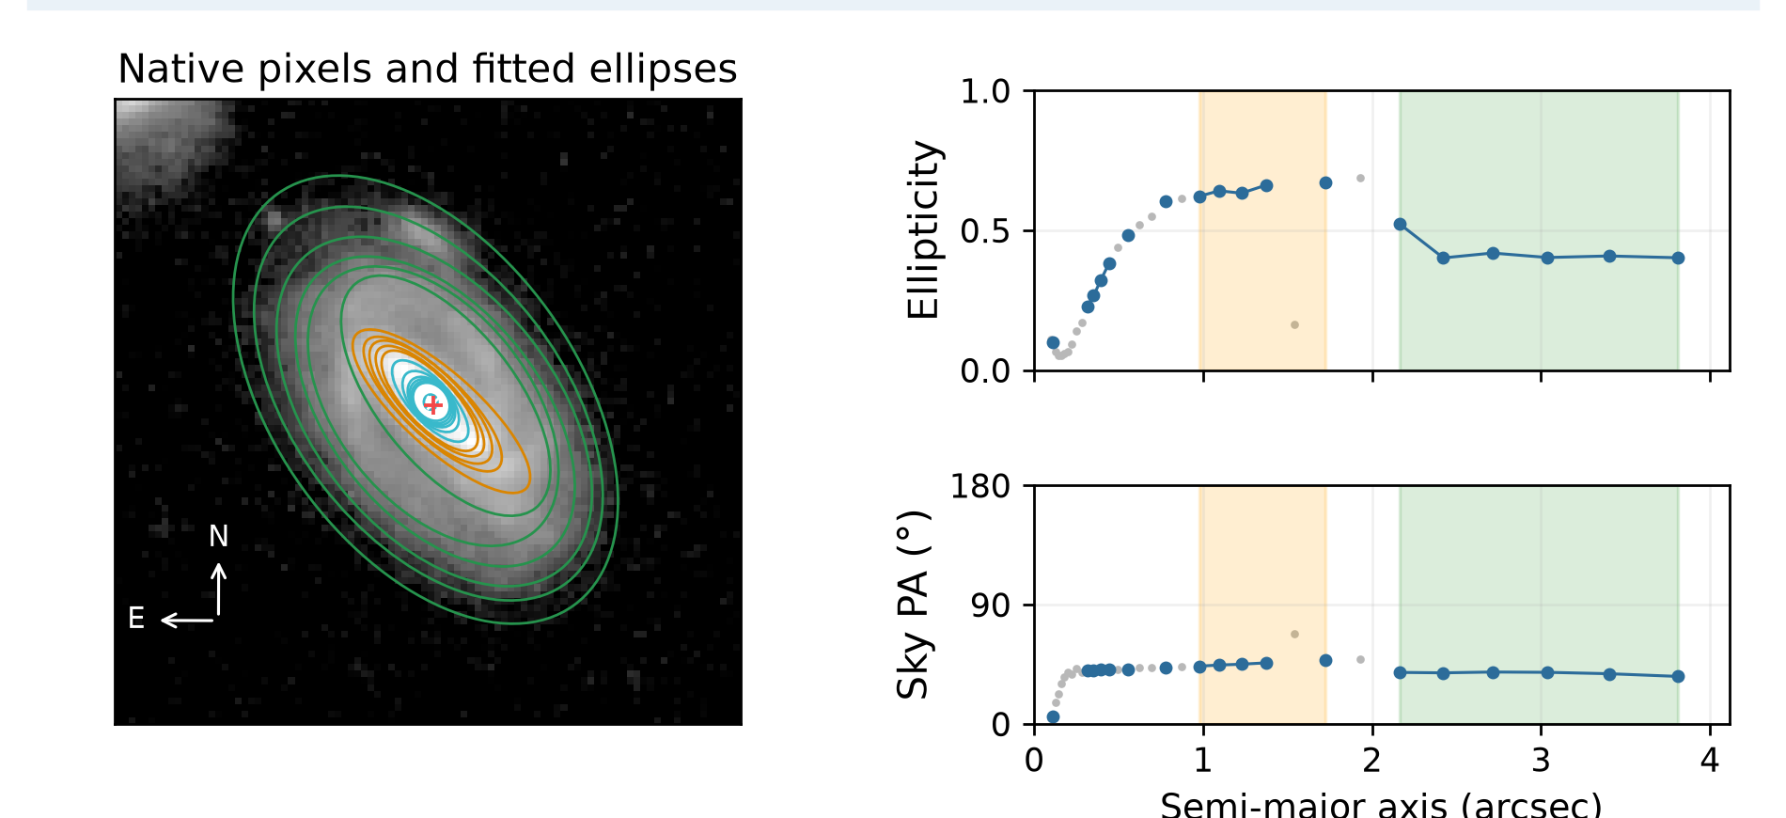
Galaxy -639567775462084647. Disc PA 38.60°; bar PA 46.34°; inclination 53.54°. Accepted disc ellipses: 6. Flags: none. Centre offset 0.032 arcsec.
Green marks the selected disc interval; orange marks the accepted bar. Look for stable outer PA, a modest ellipticity variation and a stable inner bar direction. A NoQI label screens the numerical conditions but does not independently validate the physical component identification.

Example 4 with no counted geometry issues
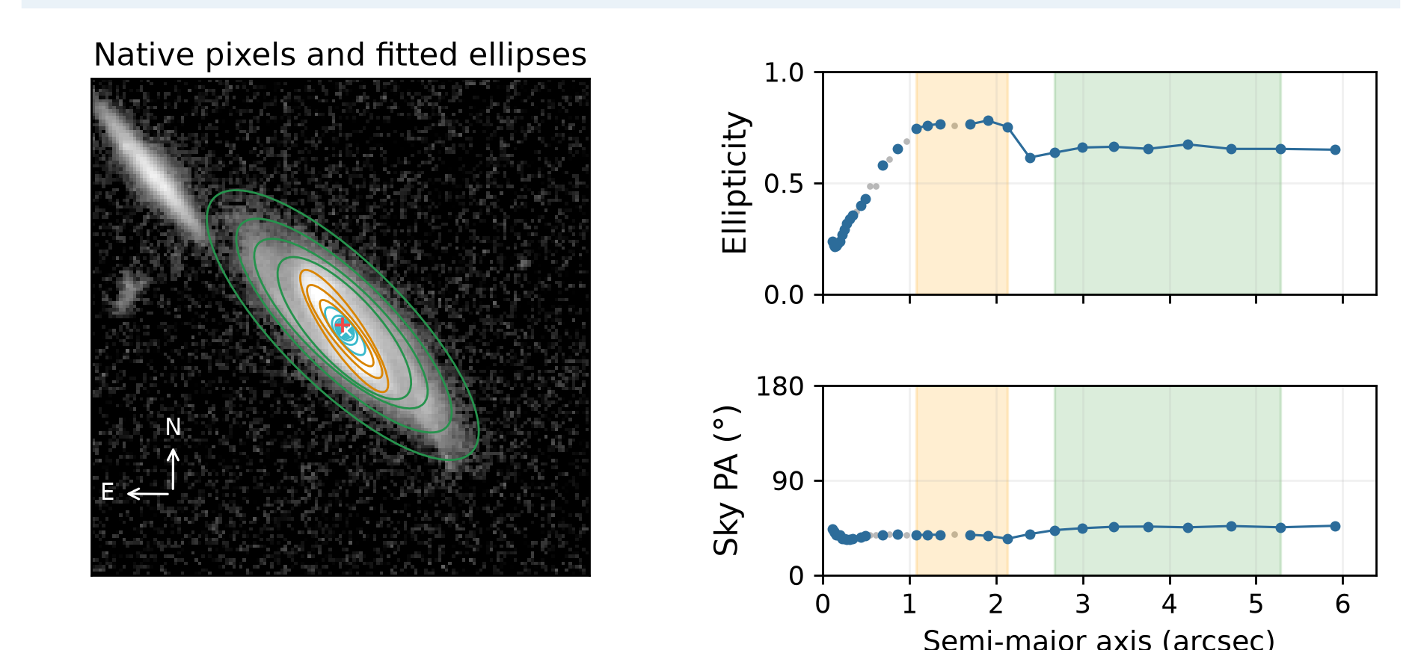
Galaxy 2652188688676008031. Disc PA 45.55°; bar PA 36.53°; inclination 69.76°. Accepted disc ellipses: 7. Flags: none. Centre offset 0.171 arcsec.
Green marks the selected disc interval; orange marks the accepted bar. Look for stable outer PA, a modest ellipticity variation and a stable inner bar direction. A NoQI label screens the numerical conditions but does not independently validate the physical component identification.

Example 1 requiring disc orientation review
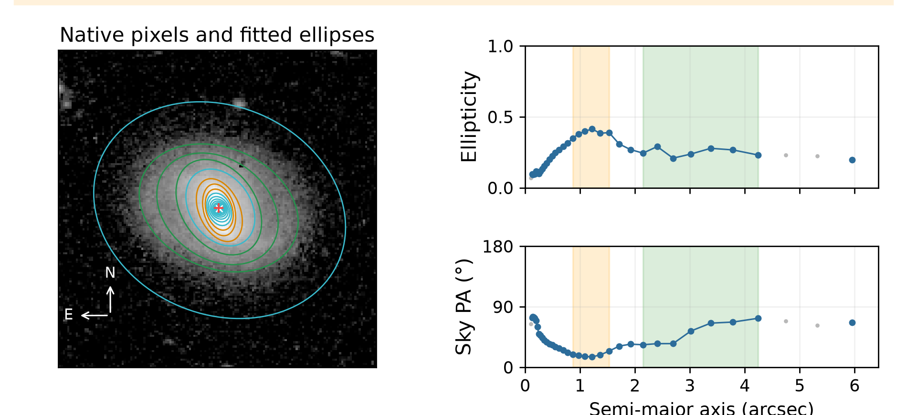
Galaxy -601121275504424227. Disc PA 60.75°; bar PA 20.23°; inclination 40.93°. Accepted disc ellipses: 7. Flags: Disc PA varies across radius. Centre offset 0.039 arcsec.
Disc PA scatter is 15.88°. The well-sampled accepted outer contours change direction. Inspect the image and profile to distinguish a systematic twist from scatter, spiral structure, contamination or centre movement.

Example 2 requiring disc orientation review
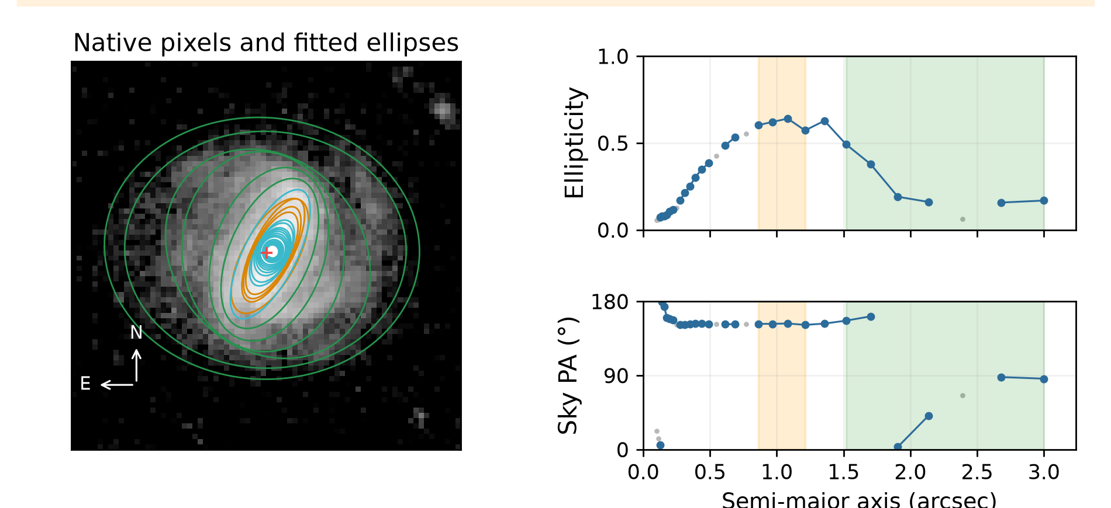
Galaxy 2708530616682862270. Disc PA 159.87°; bar PA 152.61°; inclination 34.91°. Accepted disc ellipses: 6. Flags: Changing disc ellipticity, Bar identification uncertain: small interval, Disc PA varies across radius. Centre offset 0.074 arcsec.
Disc PA scatter is 54.75°. The well-sampled accepted outer contours change direction. Inspect the image and profile to distinguish a systematic twist from scatter, spiral structure, contamination or centre movement.

Reproducibility and limits
The current run records the algorithm and catalogue hashes, method, masks, binning, centres, accepted sample counts and flags. Original science FITS files are untouched. Quality thresholds and the known-geometry synthetic test are operational checks, not an independent calibration of scientific accuracy.

Understanding the bar signature classes

What class A and class B mean
These are operational categories defined by our ellipse-fitting code. They describe how clearly the radial ellipse profiles resemble a bar. They are not Galaxy Zoo or Zoobot classes, probabilities of a bar, or measurements of physical bar strength.

The common acceptance test
A candidate must have a smoothed ellipticity peak of at least 0.20 and a plateau of at least three accepted ellipses. The plateau sky PA scatter must be no more than 10°. Beyond the peak, ellipticity must drop by at least 0.08; alternatively, a drop of at least 0.04 is accepted if the outer PA twist or difference from the preliminary outer-disc PA is at least 10°.

Class A means a clearer ellipse signature
An accepted candidate is class A only if all three stronger conditions hold: ellipticity drops by at least 0.10 beyond the peak; plateau PA scatter is no more than 5°; and peak ellipticity is at least 0.30. Ellipticity is 1 − b/a, so 0.30 corresponds to an ellipse axis ratio b/a of 0.70.

Class B means accepted with weaker evidence
A candidate is class B if it passes the common acceptance test but misses at least one class A threshold. For example, peak ellipticity 0.35, drop 0.08 and PA scatter 4° passes the common test but is B because the drop is below 0.10. Peak ellipticity 0.40, drop 0.15 and scatter 7° is also B because scatter exceeds 5°.

How to interpret the quality flag
The flag weak_ellipse_bar_signature marks every accepted class B candidate for review. Class B does not mean that the galaxy definitely has a physically weak bar. A bulge, ring or spiral arm can mimic a bar profile, including a class A profile. Inspect the image and selected ellipses before adopting the bar PA. If no candidate passes the common test, no bar PA is adopted; the disc measurement may still be retained.

Reading the profiles and assessing disc sampling

Accepted and rejected points
Blue points are accepted ellipse measurements. Grey points fail one or more acceptance checks and are excluded from the adopted disc PA and its scatter. Green shading identifies the selected radial interval; it does not mean that all points inside it are accepted. Lines connect accepted points only and now break across rejected samples. They are visual guides, not fitted curves.

Sparse sampling is distinct from PA variation
For non-face-on discs, the PA variation screen requires at least six selected accepted ellipses and no radial gap greater than half the selected span. Otherwise sparse disc sampling is flagged, while numerical PA and scatter remain in the manifest. With adequate sampling, scatter above 10° raises the radial PA variation flag. Nearly-face-on discs are exempt from both PA flags. These operational thresholds require validation; neighbouring ellipses are correlated and the count is not a number of independent observations.

Examples discussed during review
Galaxy -518633776290631360 has three selected accepted disc ellipses in the stored interval and a largest gap of about 78% of its span. A point beside the green boundary can appear to be a fourth; selection uses the stored radii. Its label is now sparse disc sampling. Galaxy -601121275504424227 has seven selected accepted disc ellipses and a largest gap of about 22%; its sustained PA change is retained as radial PA variation.

Bar candidates and failed fit displays
Galaxy Zoo and Zoobot identify bar candidates. A small selected bar interval can be a real unresolved bar or a different feature. Class A/B describes the ellipse-profile evidence, not physical bar strength or confirmation. Failed fits have no adopted centre, PA or inclination. Their report images now omit fallback centre markers and rejected ellipse overlays, which previously looked misleadingly like adopted geometry. Raw FITS pixels are unchanged.

Established catalogue identifiers
A coordinate cross-match against SIMBAD and VizieR HyperLEDA VII/237 found 227 secure positional identifications: 224 through SIMBAD and three additional VizieR matches. These have one galaxy identity within 5 arcsec and an adopted separation no greater than 2 arcsec from the Euclid catalogue coordinates. Their identifiers and match separations appear on the PNGs. No Messier, NGC or IC identifier was returned among the accepted matches. One ambiguous case and 13 candidates outside the secure radius remain unassigned. A non-match means no secure identity in these searches, not absence from all catalogues. The manifest records source, separation, link and query date; the full candidate results are retained.

Notation reference for radii and image measurements

Radii and units
r_out is the maximum accepted bright-profile semi-major axis used for selection. In a normal, non-fallback disc selection, it equals codex_disc_max_arcsec. It must not be confused with the separate view or extraction radius: the master run’s codex_radius_arcsec field serves that purpose. The bright profile normally uses background-subtracted intensity above the estimated background noise; labelled recovery can lower that threshold. Therefore r_out depends on the accepted profile and noise selection. It is not a catalogue total radius, a physical galaxy boundary or the width of the FITS image.

The selected bar end
r_bar is the notation used here for the selected bar end, called barend in the fitting code and stored as codex_bar_max_arcsec. It is the largest semi-major axis in the accepted plateau, not an independently validated physical bar length. With no accepted candidate, the code uses zero for interval selection and leaves the reported bar angle blank.

A worked disc interval
If r_out = 10 arcsec and r_bar = 3 arcsec, half the outer radius is 5 arcsec and 1.25 times the bar end is 3.75 arcsec. The larger value is 5, so the normal disc interval runs from 5 to 10 arcsec. If the bar end were 5 arcsec, the interval would instead start at 6.25 arcsec. The adopted boundaries are stored as codex_disc_min_arcsec and codex_disc_max_arcsec. A fallback may use the outermost three bright accepted measurements instead.

Segmentation scale and image coordinates
r_seg is the equivalent circular radius derived from the catalogue segmentation area. It starts in native pixels, whereas r_out and r_bar are in arcseconds. One arcsecond (arcsec or the double-prime symbol) is 1/3600 of a degree; one arcminute is 60 arcseconds. A pixel is one image sample. Pixel scale is the angular size of a native pixel, in arcseconds per pixel. Binning combines native pixels for fitting; a fit pixel can therefore cover several native pixels. Centre offsets and scatter quoted in arcseconds are converted using the pixel scale.

Brightness and noise
Intensity is the fitted average brightness along an ellipse, in the image data units after background subtraction. Background is the estimated sky level. Sigma denotes a standard-deviation scale; sigma-clipping iteratively excludes outlying values when estimating the background and noise. Coverage is the usable fraction of sampled positions along a particular ellipse, not a fraction of the galaxy area. Normal convergence means Photutils reached its numerical stopping condition; it does not validate the physical component identification. Stop codes describe the fitting termination; they are not physical galaxy properties.

Notation reference for shape and angle calculations

Ellipse shape and inclination
a and b are the ellipse semi-major and semi-minor axes, measured in the same units. Their ratio q = b/a is dimensionless. Ellipticity, also written epsilon or ε, is 1 − q; a circle has ε = 0. The median selected-disc ellipticity supplies the adopted q. Inclination i is the angle of the disc away from face-on, in degrees. q0 (also written q₀) is the assumed intrinsic edge-on thickness ratio, not an observed ellipticity. No thickness correction is applied when q0 = 0.

Disc and bar angles
PA means position angle, in degrees. Disc PA and bar PA both describe projected axes on the observed sky, from North towards East, modulo 180°. They are not inclinations or face-on bar angles. The plotted semi-major axis is a radial distance in arcseconds. East and North in atan2(East, North) are signed local sky offsets obtained through WCS, in the same angular units. atan2 determines the orientation, including its quadrant; converting to degrees and taking modulo 180° produces the reported sky PA.

Weights and axial averaging
For each accepted ellipse, its PA error is the estimated angular fitting error in degrees. Its weight is the reciprocal of the square of the larger of that error and 0.3°. The 0.3° floor prevents a tiny reported error from dominating. An axial mean treats orientations separated by 180° as identical; it averages doubled angles and then halves the result. Thus 1° and 179° average near 0°, rather than 90°.

Scatter and radial coverage
PA RMS scatter is the root mean square of wrapped angular differences about the unweighted axial mean of the selected angles; each difference lies between −90° and +90°. It uses equal sample weights, unlike the adopted weighted PA. It is measured in degrees, and adjacent ellipses are correlated. Radial span is the outermost selected radius minus the innermost. Largest gap is the greatest spacing between consecutive selected radii; largest gap divided by span is dimensionless, often shown as a percentage. Ellipticity span is the maximum minus minimum selected ellipticity and is dimensionless.

Functions and labels
sqrt means square root; acos means inverse cosine; max selects the largest supplied value; min selects the smallest. Multiplication is indicated by a space or by “times”. A median is the middle ordered value. FITS is Flexible Image Transport System. WCS is World Coordinate System. Class A and B are the operational bar-signature classes explained earlier. QI and NoQI are review labels, not statistical confidence levels. Names such as disc_range_fallback and codex_information are manifest fields or flag labels, not additional mathematical variables.

